March 21, 2026 Family Learning Day Course Descriptions
Registration: 8:45 to 9:00 AM
Session 1 (9:15 – 10:15 AM) | Session 2 (10:30 – 11:30 AM) | Session 3 (12:30 – 1:30 PM) | Session 4 (1:45 – 2:45 PM)
Basket weaving Double session |  | Basket weaving Double session
Hat & Neck Warmer | Hat & Neck Warmer | Sewing: Toy/Tote Bag | Sewing: Toy/Tote Bag
Pigs/Swine 101 | Sheep | YQCA double session
Beef 101 | Rural to Real World | Lego 4 in 1 | Sparks your Sparks
Loom Knitted Stocking Hats  Double session |  | Loom Knitted Stocking Hats  Double session
Rabbit 101 | Rabbits Showmanship and Terms | Gearing up for 4-H Camp 2026 | Butter Boards & Dairy Promotion
Cheesemaking | So you want to be a farmer | Trapping | Trapping

Member Experiences: Join us in the Commons during lunch to hear about some additional member experiences on the National Level from Olivia and Isabella

Course Descriptions
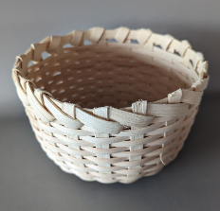
Basket Weaving Terri Feutz
Limited to 10 participants per session.
Basket Weaving — Ages 10 to 99 (younger with parent assist)
Learn the basics of basket weaving as you create your own basket from a wooden base, weave up the sides, and finish with a folded rim. All materials and tools are provided. Come ready to learn a timeless craft!

Beef 101 Paige Lester
Are you a new or young beef project member? Learn about your beef project, discover the answers to your project questions, and find out who to ask if you have more questions. We will review items needed for the fair and the process for entries. Older youth exhibitors are encouraged to attend to assist new members. Counts for 1 point on Livestock Education Orange Card.

Butter Boards & Dairy Promotion Funding: Brenda Conley
A butter board is made with softened butter spread onto a board and paired with fun ingredients. You will make your own homemade butter and flavored boards! We will also go over the 4-H Dairy Promotion funding ($100/club). This session is required if your club is requesting Dairy Promotion funding this year. Counts for 1 point on Dairy Project Member Activity Card.

Cheese Making Charles Crave
Join the dairy fun and become a cheese-making maestro! Learn to make cheese and culture yogurt. Counts for one point on Dairy Project Member Activity Card. Say cheese!

So You Want to Be a Farmer? Charles Crave
Dreaming of life on the farm? Join us for a chat about the journey to becoming a farmer. Learn how the Crave family started farming and get tips on pursuing a farming career. Counts for 1 point on Dairy Project Member Activity Card.

Gearing Up for 4-H Camp 2026: Penny Seaver and others
Join this engaging session to learn more about the exciting growth opportunities at 4-H Camp 2026.

Hat & Neck Warmer Cindy Schlimgen
Limit of 6 participants per session
Back by popular demand! Create a matching set to keep you warm. This sewing session is perfect for those looking to practice their machine skills and walk away with a functional winter accessory. (Limit of 6 participants).

Loom-Knitted Stocking Hats — Beginner Friendly! Mary Link
Learn how to knit a cozy stocking hat using a simple round loom—no experience needed. This two-session class gives you plenty of time to complete your project and enjoy a relaxing, hands-on craft.
What to Bring:
- A round knitting loom
- A loom pick
- A skein of yarn (thicker yarn recommended—not blanket yarn)
Looms are easy to find at Hobby Lobby, Walmart, Michael’s, Amazon, or any store that sells yarn. Loom sets usually include a pick and needle. If you’re using your own or borrowing a loom, be sure you have a loom pick; they can also be purchased separately. And don’t forget your yarn—choose a thicker skein similar to this:
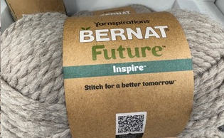
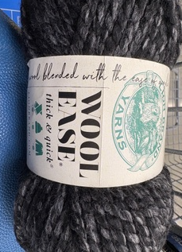
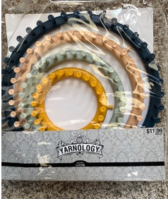
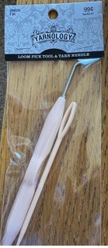

Legos: Harper Slechta
Limited to 12 participants per session. Extra $5 session fee
Blast off into creativity as participants build and transform their own 4-in-1 Sky Robot from Brick Blocks! Youth will explore engineering concepts while creating robots that can fly, patrol, and explore imaginary galaxies. Get ready for hands-on building and out-of-this-world fun! Geared toward 6 and up, but 6-9 year olds need a parent to help them. There are a lot of smaller parts.

Rabbit Showmanship and Terms Vicki Redecker & Kendall Wrucke
Come learn about how to present the best showmanship at the fair and learn the terms needed to succeed! "Counts as 1 point on either the purple card OR sale activity sheet"

Rabbit Breeds 101 Vicki Redecker & Kendall Wrucke
Come learn about the many recognized breeds of rabbits to raise and show. "Counts as 1 point on either the purple card OR sale activity sheet"

Pigs/Swine 101 Courtni Salmi
A beginner’s swine class for new members and parents. We will cover all required tools for showing, paperwork from start to finish, DNA samples, ear tagging, and a "play-by-play" of what to expect each day at the fair. Counts for 1 point on Livestock Education Orange Card.

Rural to Real World: Translating Your Rural Experiences for College & Career College for Rural Wisconsin (Jennifer Blazek)
Where do see yourself after high school? You may or may not be thinking about going to college, but everyone is going to have a career. Learn from rural college students about goal-setting and how to talk about your rural experiences for a job resume or a college admissions application. You’ll work through an activity that helps you to create a standout resume! Best for High Schoolers.

Sewing: Smaller Tote or Toy Bag Cindy Schlimgen
Limit of 6 participants per session
Ready to stitch something sweet? Join us for a hands-on workshop where you’ll craft a small, adorable, 100% cotton tote bag. This beginner-friendly class covers the essentials of bag construction, including working with durable natural fibers and adding a contrasting interior liner for a pop of color. You’ll walk away with a sturdy, machine-washable accessory and the skills to tackle your next sewing project with confidence.

Sheep 101 Maria Meier
Learn the basics of preparing a sheep project for the county fair, from selecting and purchasing a lamb to feeding, exercise, and the final steps leading up to fair time. Counts for one point on Livestock Project Member Activity Card

Sparks your Sparks Marie Witzel
Identify your "Spark” -- the deep interests or talents you love. Through three interactive activities, you’ll find what excites you and connect with others who can encourage your journey.

Trapping Ken Tietz
Learn about trapping through an overview of fur collection and an introduction to different types of traps and their uses.

YQCA (Youth for the Quality Care of Animals) Double Session Alice Kern
This required certification class helps youth learn about proper animal care and food safety. Note: Youth must also register and pay the $3 fee at yqcaprogram.org to receive their certificate.

