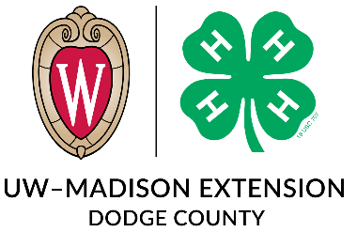
DODGE COUNTY 4-H
KEY AWARD AND EDUCATIONAL EXPERIENCES
SCHOLARSHIPS APPLICATION
Name: ____________________________________ Grade (as of Oct 1st): _____________________
Email: ___________________________________________________________________________
Phone:____________________________ 4-H Club: ______________________________________
Please rank the trip scholarships you wish to be considered for in order of your preference:
(1 = Highest Preference, 7 = Lowest) If you are not interested/eligible, please leave it blank.
______ Space Camp, Huntsville Alabama (Grades 6-8)
______ Summer Academy, Madison WI (Grades 8-11)
______ American Spirit East, Philadelphia, NYC, Boston, Niagara Falls (Grades 8-10)
______ Ignite by 4-H: STEM or Animal Science Track Washington DC (Grades 10-12)
______ 4-H Citizenship Washington Focus @ Ignite, Washington DC (Grades 10-12)
______ National 4-H Congress, Atlanta Georgia (Grades 10-12)
______ National 4-H Conference, Washington DC (Grades 10-12)
**An additional state application process must also be completed.
**Most trips require participants to pay for half of the cost of the trip and the Dodge County 4-H Leaders Association will pay for the other half.
Please check below if you are interested in being considered:
______ Wisconsin 4-H Key Award (Grades 9-13)
*Must have completed at least 3 years in 4-H*
PLEASE NOTE: All application materials MUST be received at the Dodge County Extension Office by November 1st. Interviews will be coordinated with each applicant as trip registration details are available.
A completed application packet will include:
- Dodge County 4-H Key Award and Educational Experiences Scholarship Application
- Cover Letter
- Resume
- Reference page with three references (including their name, address, and phone number). One should be your club or project leader, the other two can be people of your choice.

