Positive Youth Development Programming:
January-March 2025

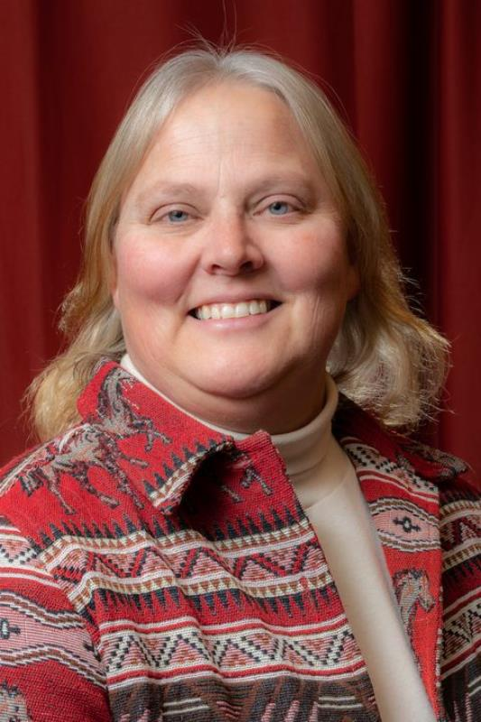
Marie Witzel
Positive Youth Development Educator
UW Madison Extension Dodge County

Needs Assessment
- Youth have an opportunity to explore their spark(s)
- As the focus on program quality and the Developmental Context continues, overall program quality increases
- Youth engagement increases in county level programming

AmeriCorp member started with a focus to expand access to youth programs to additional audiences

- She offered a program at the Randolph library in January They made ribbon flowers, embroidered bookmarks and Valentine’s Day Cards. It was a new partnership with Randolph library this year.
- March was a program at the Lomira Library to focus on breakout boxes of challenges, travel first aid and paracord bracelets

4-H journey to career success! In this interactive and engaging class, helps youth master the art of crafting a standout cover letter, and building a winning resume. this session will equip youth with the essential tools and tips to shine

A series of meetings, work-dates, and counselor interviews and training for the purpose of planning a 4-H camp for youth from Columbia, Dodge, and Sauk counties. The camp goal is bringing youth together to try new activities, make new friends, and experience nature and time away from home in a safe setting.

Family Learning Day in February was cancelled, however March was bursting with energy. Over 205 youth were registered for the program with several additional walk ins that day. They could choose from 4 different sessions during the day to explore their sparks. From the evaluations the overall organization rated 75% rated it as excellent, 67% rated the workshop quality as excellent, and 78 % rated the venue and facility as excellent.

Youth also attended educational project programs taught by volunteers. Those included
- Archery
- Air pistol and .22
- Livestock
- Poulty
- Rabbits and Cavies
- Horse
- Dairy

Current Projects
- Continued Project learning
- Summer member experience planning
- Safety day with progressive ag and powersports
- Counselor training
- Summer camp
- summer AmeriCorp programs
- Education at the county fair

