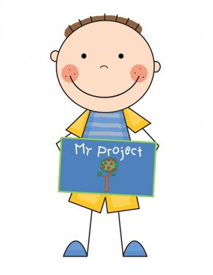


Demonstration & Illustrated Talk Contest

Monday, March 31 – 6:30 PM
Dodge County Administration Building
127 E. Oak Street, Juneau WI
Demonstrations are more showing and doing. Illustrated Talks rely more on charts, pictures, and description. For topic ideas, check with your general leader or the 4-H Office.
Many of you have given brief demonstrations or talks at 4-H meetings. Just polish up the presentation. Do not use school presentations! Please, no product labels.

Divisions and Time Guidelines
Grade 5K-2 5 minutes or less
Grades 3-4-5-6 6 minutes or less
Grades 7-8-9 5-8 minutes
Grades 10 & up 5-8 minutes

There is no minimum time limit for grades 1-6, but at least 4 minutes is suggested. Participants will be judged on: clear, pleasant voice/self-confidence, enthusiasm/poise, appearance/posture, appropriate introduction, accurate information, visual aids, orderly progression, summarization, adequate preparation, interesting subject, and purpose accomplished. Easels will be provided.
Team Demonstrations (two members) may also be given. In a team demonstration, the grade division is that of the older member. The older member also determines time guidelines.
- Participants will be scheduled by grade to give demonstrations.
- Top demonstrators in each grade group will be selected.
- Upon completion of the contest, ribbons will be awarded and top demonstrators will be announced.
- No reminder letters are sent!

If unable to attend after registering, you are expected to call the Extension office at 920-386-3790.
Sign up in 4HOnline.com
DEADLINE: March 26, 2025

