February 15, 2025
Family Learning Day Schedule
Horicon High School 841 Gray St Horicon, WI 53032
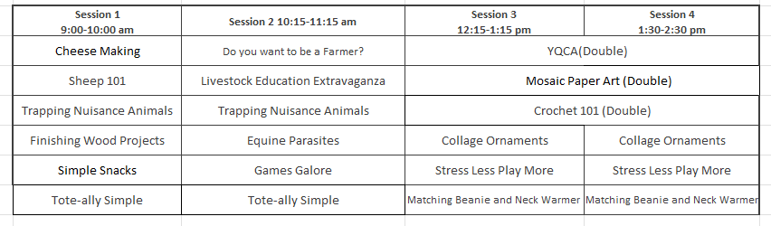
Family Learning Day Descriptions

Cheese Making (Session 1) Charles Crave
Join the dairy fun and become a cheese-making maestro! Learn to make cheese and culture yogurt. Counts for one point on Dairy Project Member Activity Card. Say cheese!
Collage Ornaments (Session 3 or 4) Molly Damm
Bring your creativity in this hands-on workshop where you’ll craft unique ornaments using a mix of materials from paper, paint, and glitter and more! Explore layering techniques, play with textures, and design a personalized ornament for any time of year. No prior experience needed—just bring your imagination!
Crochet 101 (Double Session 3&4) Lisa Shuppe $5.00 Fee
Discover the joy of crochet in this beginner-friendly class! Whether you're new to the craft or looking to refresh your skills, this course will guide you through the basics of crochet. Learn essential techniques, from creating simple stitches to completing your first project. We will be making a Backpack Bug so join us for a fun and relaxing experience and leave with the confidence to start your own crochet journey!
Do You Want to Be a Farmer Someday? (Session 2) Charles Crave
Dreaming of life on the farm? Join us for a chat about the journey to becoming a farmer. Learn how the Crave family started farming and get tips on pursuing a farming career. Counts for 1 point on Dairy Project Member Activity Card.
Equine Parasites (Session 2)
Gallop into the world of equine parasites! Learn about causes, identification, and treatment with a fun hands-on activity matching CANDY to parasites.
Finishing Wood Projects (Session 1) Rich Grulke
Get your hands dirty and learn the art of finishing wood projects! We'll cover sandpaper, stains, and finishes. Wear clothes that can handle a little mess and bring your questions! (Limit 10)
Games Galore (Session 2) Heather Wampler
Get ready to play and have a blast! Learn new games that will get your heart pumping and your blood flowing. Gym shoes required; open to all ages; no limit on participants.
Livestock Education Extravaganza: Where Learning Meets Fun! (Session 2) Amy Voigt and Sandy Salmi. Counts as one (1) point on the orange Livestock Project Member Activity Card
Step into a world where livestock education comes alive with excitement! Join us for an unforgettable experience as we dive into the fascinating realm of livestock through engaging Kahoot trivia games.
- Interactive Trivia Games: Test your knowledge and compete with friends in lively Kahoot quizzes that make learning about livestock a blast.
- Fun-Filled Sessions: Say goodbye to boring lectures and hello to dynamic, interactive sessions that keep you on your toes.
Don't miss out on this unique opportunity to learn, laugh, and connect with fellow enthusiasts. Let's turn livestock education into an adventure you won't forget!

Matching Fleece Beanie and Neck Warmer (Session 3 or 4): Limit 6. An adult must accompany youth under the age of 10. Cindy Schlimgen
Brrr...it's cold out---let's make a hat and neck warmer set! This class is for beginners, but all levels are encouraged to attend. In this session we will make a matching fleece beanie hat and neck warmer (aka a neck gaiter). We'll use digital and self-drafted patterns and zig-zag stitches. This will be made from warm, cozy fleece, and matching thread. Materials will be supplied but if you have a fun fleece you'd like to use, feel free to bring that (you'll need 1/2 yard of fabric for a set). We'll use a free online beanie pattern from Scattered Thoughts of a Crafty Mom (free at Scattered Thoughts of a Crafty Mom - Home Page); the neck warmer requires no pattern. *Please bring the following if you have them: a pair of fabric scissors, measuring tape, stick pins/clips.
Mosaic Paper Art (Double session 3 & 4) Heather Wampler
Unleash your inner artist and create beautiful mosaic art! Turn any picture into a colorful masterpiece. No limit on participants; 1st grade and up.
Simple Snacks (Session 1) Heather Wampler
Snack attack! Learn to make tasty, simple snacks for you and your family. Leave with delicious recipes. Limit 15 participants; all ages welcome, but youth grades 2 and younger must be accompanied by a responsible adult. There will be a cost for supplies, determined by the number of participants signed up.
Sheep 101: For Beginners (Session 1) Josh Voigt and Amy Voigt. This is a discussion for new sheep members and will cover the basic information needed to make this a successful year, and to be able to show at the Dodge County Fair. It is for all those questions the new exhibitor doesn't realize they need to ask. *Counts for one point on the Livestock Project Member Activity Card.

Stress Less, Play More: Mastering Life's Decisions (Session 3 or 4) Marie Witzel
School can be tough, but dealing with stress and making decisions doesn't have to be! Join us for a fun and interactive class where you'll learn how to handle stress and make smart choices through engaging activities and a hands-on game.

Tote-ally Simple (Session 1 or 2). Limit 6. An adult must accompany youth under the age of 10. Cindy Schlimgen
Looking for a simple project to sew? Need a quick gift? Attend this session to make a fast and easy tote bag with just a half a yard of fabric. We'll use straight and zig-zag stitches and a simple seam finish. This will be made from woven fabric, webbing, and matching thread. Materials will be supplied but if you have a fun woven cotton fabric you'd like to use, feel free to bring that (you'll need 1/2 yard of fabric for each tote bag). We'll use a pattern from Purl So-Ho (free at www.purlsoho.com). *Please bring the following if you have them: a pair of fabric scissors, measuring tape, stick pins/clips.
Trapping Nuisance Animals (Session 1or 2) Ken Tietz
Get trapped in the world of trapping! Ken will showcase his collection of furs and unique animal pictures. Learn about different traps and how to use them. Ken will answer all your questions.
YQCA (Double Session 3 and 4) Alice Kern
Ages 8-18 as of January 1st. Youth for the Quality Care of Animals. Learn about caring for your animal projects and ensuring a quality food product. Required for youth showing beef, dairy, sheep, swine, goats, rabbits, or poultry at the state fair. Required for county fair beef, sheep, and swine exhibitors. Additionally, enroll for certification at https://yqcaprogram.org/ and make a payment online ($3). This registration is needed in addition to the Family Learning Day registration. This fulfills the required YQCA class on your Dairy, Livestock, and Small Animal Project Member Activity Card.

