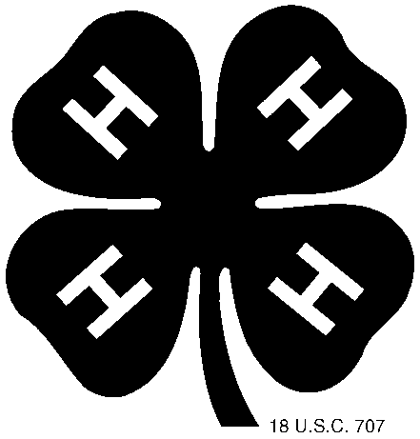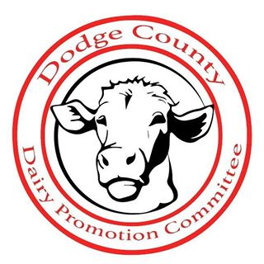

Dodge County 4-H Dairy Promotion Funding & Contest
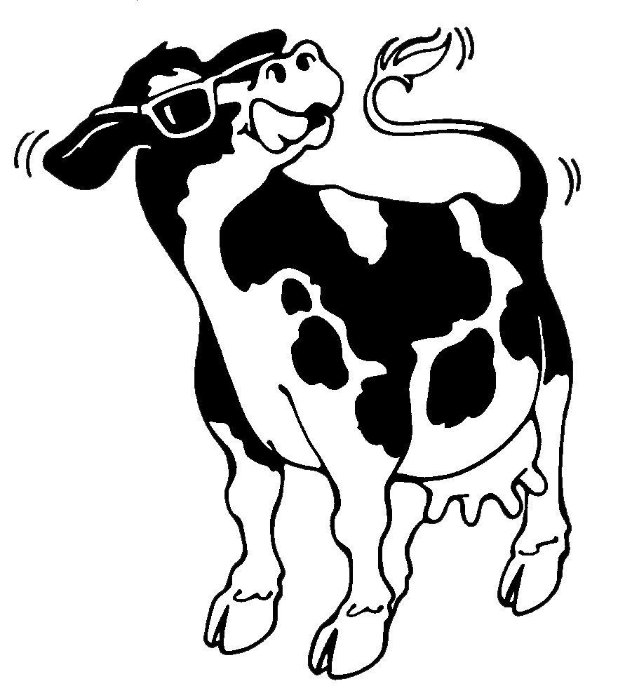

YEAR 2024
4-H DAIRY PROMOTION FUNDING REQUEST FORM
If someone from your club has attended the Dairy Promotion session at Family Learning Day and club members will be helping at the Dodge County Dairy Brunch, you must complete this form and return it by June 1ST. You will receive money from the Dairy Promotion Committee ($50) and WI Women for Agriculture-Rock River Chapter ($25) to carry out your promotion activities in 2024.
4-H CLUB:_________________________________________________________________

Contact Person:_______________________________________________________________
Address: ____________________________________________________________________
Telephone:____________________ Email: _______________________________

1. Describe the type of promotions that you plan to carry out in 2024 with the money received from the Dodge County Dairy Promotion Committee & WI Women for Agriculture-Rock River Chapter (include OBJECTIVES for each activity: when/where it might take place, and any other ideas you can share):

TYPE OF ACTIVITY/PROMOTION TIME FRAME/DATES OBJECTIVE

____________________________________________________________
____________________________________________________________
____________________________________________________________
____________________________________________________________
____________________________________________________________
____________________________________________________________

PLEASE COMPLETE THIS FORM BY JUNE 1ST
TO THE EXTENSION OFFICE

Please return to the 4-H Office
by September 17, 2024

Dairy Promotion Funding Financial Report

Club Name: ________________________________________________

TYPE OF ACTIVITY/PROMOTION DATES

____________________________________________________________
____________________________________________________________
____________________________________________________________
____________________________________________________________

Financial Statement:
Total Money Received: $ ________________
Money Club Contributed: $ ________________
TOTAL: $ ________________

How was the money spent? [Please submit copies of receipts!]:

Education $ ________________
Dairy Products $ ________________
Promotional Materials $ ________________
Other Materials (catalog items, other) $ ________________
TOTAL SPENT: $ ________________

Club Treasurer Signature: ________________________ Date: ______________

General Leader Signature: ________________________ Date: ______________
DODGE COUNTY 4-H DAIRY PROMOTION CONTEST

Our objective is to educate adults/children about the nutritional value of dairy products and to give the community facts about dairy farming and related dairy industries. The goal of these programs has been to increase sales of dairy products and to enhance the image of area farmers and related dairy industries.

Every 4-H Club in Dodge County is invited to participate in the Dodge County Dairy Promotion Contest. Any club can participate, regardless if they have or do not have a dairy leader or group. You are to report on only ONE dairy promotion activity that your club has participated in. You may do more than one dairy promotion activity for your club, but please submit only ONE activity to be judged. Complete the enclosed report for a chance to win funds for your club.

In the past, it was required for both the dairy promotion funding and the dairy promotion contest to attend the Family Learning Day session and help at our Dairy Brunch. For the Dairy Promotion Contest only, these requirements will be dropped BUT you will score extra points if you have done either of the past requirements. This requirement will still be in effect when requesting Dairy Promotion Funding.

The completed Dairy Promotion Report will be due at the Extension office on the same day the Record books are due in September. We have also provided you with a copy of the scoring sheet that will be used to evaluate your reports. Any reports that are incomplete can be disqualified at the discretion of the Dairy Promotion Committee. The Dairy Promotion forms can be downloaded on the Extension website.

The awards for the top reports are as follows:

1st Place $40
2nd Place $30
Most Innovative Idea $20

Any club can win the 1st or 2nd placings AND the Most Innovative Activity award

If you have any questions or need assistance, please feel free to contact the following:

Extension Dodge County Brenda Conley
Dodge County 4-H Dodge County Dairy Ambassador
920-386-3790 262-224-2559

Thank you for promoting dairy in Dodge County!

4-H DODGE COUNTY DAIRY PROMOTION CONTEST SCORESHEET

CLUB NAME DAIRY PROMOTION ACTIVITY
Did a club member attend the Dairy Promotion Family Learning Day Session? □Yes □No
Did club members help at the Dairy Brunch? □Yes □No
Judging Criteria | Possible Points | Points Earned | Comments
Did the club work as a team and utilize a community facility/resource? | 20
Did the club effectively promote dairy? | 40
Financial Documentation  (IE financial statements, receipts, etc) | 15
Documentation  (IE newspaper clippings, photos, supporting materials, social media, screenshots, etc) | 15
Neat & Well Organized Report (Preferred to be filled out by a 4-H member, not the leader) | 10
Came to Family Learning Day Session | 25
Helped at the Dairy Brunch | 25
TOTAL POINTS | 150
Innovative Idea *Bonus Points* | 50
Additional Comments: ___________________________________________________
___________________________________________________________________
4-H CLUB BEST DAIRY PROMOTION ACTIVITY REPORT FORM

CLUB NAME:

REPORT PREPARED BY:

ADULT LEADER(S):

NAME:

STREET ADDRESS:

CITY/STATE/ZIP:

PHONE: (___) E-Mail:

YOUTH LEADER(S):

NAME:

PHONE: ( ) E-Mail:

Total # of members in the club: _______________

# of members of the club that helped at your event: ____________

# of members that helped at the Dairy Brunch: _________________

# of members that attended the Dairy Promotion Family Learning: _________

4-H CLUB BEST DAIRY PROMOTION ACTIVITY REPORT FORM

Name of Promotion: _____________________________________________________

Brief Description of Promotion:

Purpose of Promotion/What did you hope to accomplish?:

Date and time of promotion:

Place held:

Did anyone outside of your club helped with the promotion?:

Results of promotion (IE.: Number of coupons redeemed, etc.):

Est. number of people reached: Budget for activity (optional): $

Media coverage:

Do you feel this promotion was successful? Why?:

4-H CLUB BEST DAIRY PROMOTION ACTIVITY REPORT FORM

DOCUMENTATION & FINACIALS

