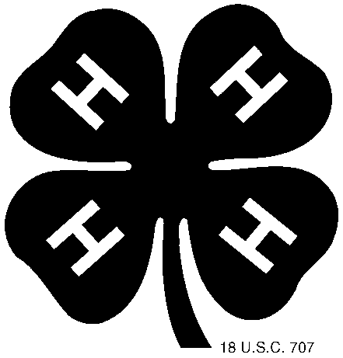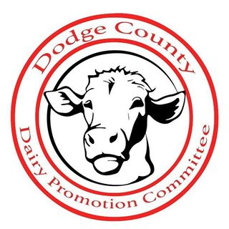

Dodge County 4-H Dairy Promotion Contest Information
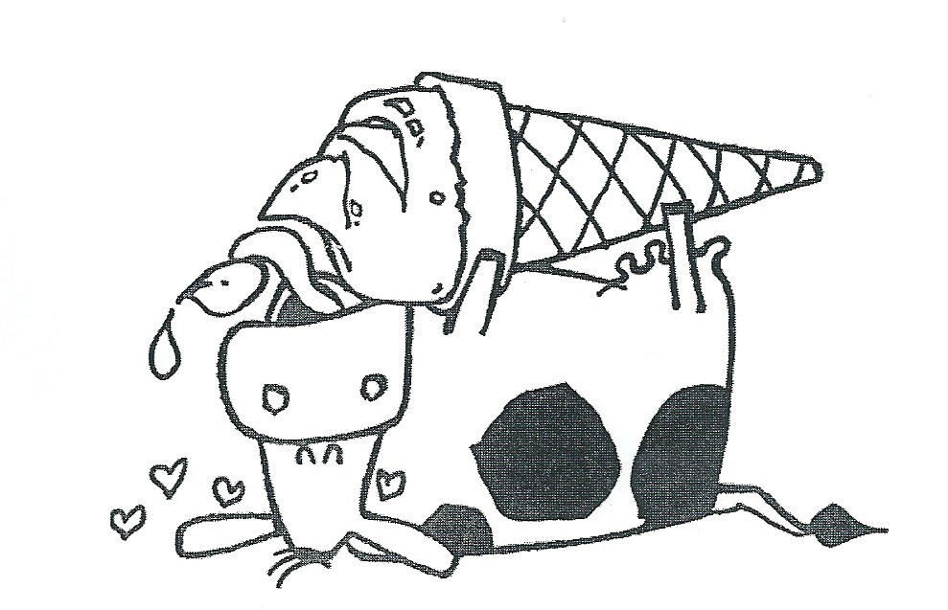

DODGE COUNTY 4-H DAIRY PROMOTION CONTEST

Our objective is to educate adults/children about the nutritional value of dairy products and to give the community facts about dairy farming and related dairy industries. The goal of these programs has been to increase sales of dairy products and to enhance the image of area farmers and related dairy industries.

Every 4-H Club in Dodge County is invited to participate in the Dodge County Dairy Promotion Contest. Any club can participate, regardless if they have or do not have a dairy leader or group. You are to report on only ONE dairy promotion activity that your club has participated in. You may do more than one dairy promotion activity for your club, but please submit only ONE activity to be judged. Complete the enclosed report for a chance to win funds for your club.

There are two requirements to be eligible:
- At least 1 club member must attend a Dairy Promotion session at Family Learning Day – NOT APPLICABLE IN 2021;
- a minimum of 20% of the club members must help at the Dairy brunch in June.

If both of these are not met, we reserve the right to disqualify the report.

The completed Dairy Promotion Report will be due at the Extension office on the same day the Record books are due. We have also provided you with a copy of the new scoring sheet that will be used to evaluate your reports. Any reports that are incomplete can be disqualified at the discretion of the Dairy Promotion Committee. The Dairy Promotion forms can be downloaded on the Extension website.

The awards for the top reports are as follows:

1St Place $40 2Nd Place $30
Most Innovative Idea $20

Any club can win the 1st or 2nd placings AND the Most Innovative Activity award.

If you have any questions or need assistance, please feel free to contact the following:

Extension Dodge County Brenda Conley
Dodge County 4-H Dodge County Dairy Ambassador 920-386-3790 920-625-3691
Thank you for promoting dairy in Dodge County!

4-H DODGE COUNTY DAIRY PROMOTION CONTEST SCORESHEET

CLUB NAME DAIRY PROMOTION ACTIVITY

Judging Criteria | Possible Points | Points Earned | Comments
Did the club work as a team and utilize a community facility/resource? | 20
Did the club effectively promote dairy? | 40
Financial Documentation  (IE financial statements, receipts, etc) | 15
Documentation  (IE newspaper clippings, photos, supporting materials,  social media, etc) | 15
Neat & Well Organized Report (Preferred to be filled out by a 4-H member,  not the leader) | 10
TOTAL POINTS | 100
Innovative Idea *Bonus Points* | 15
Did a club member attend the Dairy Promotion Family Learning Day Session? □Yes □No Did 20% or more of your club members help at the Dairy Brunch? □Yes □No

COMMENTS:

DODGE COUNTY DAIRY PROMOTION MISSION STATEMENT:
The main focus of the organization has been to educate adults/children about the nutritional value of dairy products and to give the community the facts about dairy farming and related dairy industries.
The goal of these programs has been to increase sales of dairy products and to enhance the image of area farmers and related industries.

YEAR 2021
DAIRY PROMOTION COMMITTEE/4-H REQUEST FORM
4-H CLUB:

Contact Person:

Address:

Telephone:

1. Describe the type of promotions that you plan to carry out in 2021 with the money received from the Dodge County Dairy Promotion Committee & WI Women for Agriculture-Rock River Chapter (include OBJECTIVES for each activity, when/where it might take place, and any other ideas you can share):

TYPE OF ACTIVITY/PROMOTION TIME FRAME OBJECTIVE

If you complete this form, return it by June 1, 2021 and attend a session on Dairy Promotion at Family Learning Day, you will receive money from the Dairy Promotion Committee and WWA-Rock River Chapter to carry out your promotion activities in 2021.

Due JUNE 1, 2021 to: Dodge County 4-H, 127 E Oak Street, Juneau, WI 53039

4-H CLUB
BEST DAIRY PROMOTION ACTIVITY REPORT FORM

CLUB NAME:

COUNTY:

ADULT LEADER (DAIRY PROMOTION):

NAME:

STREET ADDRESS:

CITY/STATE/ZIP:

PHONE: ( )

E-Mail:

YOUTH LEADERS:

NAME:

STREET ADDRESS:

CITY/STATE/ZIP:

PHONE: ( )

NAME:

STREET ADDRESS:

CITY/STATE/ZIP:

PHONE: ( )

Report prepared by:

PHONE: ( )

E-Mail:

Other committee members:

(Page 1 of 2)

Name of promotion

Brief description of promotion:

Purpose of promotion (What did you hope to accomplish?):

Date and time of promotion:

Place held:

Who (outside of your club) helped with the promotion:

Results of promotion (What did you accomplish? i.e.: Number of coupons redeemed, etc.):

Est. number of people reached: Budget for activity (optional): $

Media coverage (include clippings or tapes if possible):

Do you feel this promotion was successful? Why?

(Page 2 of 2)

Please return with your Dairy Promotion Report to the 4-H Office by September 3, 2021

Club Name
Dairy Promotion Committee Financial Report
DODGE COUNTY DAIRY PROMOTION MISSION STATEMENT:
The main focus of the organization has been to educate adults/children about the nutritional value of dairy products and to give the community the facts about dairy farming and related dairy industries.
The goal of these programs has been to increase sales of dairy products and to enhance the image of area farmers and related industries.

Explain how YOUR club used the money to support this mission statement:

Financial Statement:
Total Money Received: $
Money Club Contributed: $
TOTAL: $
How was the money spent [Please itemize and submit receipts!]: (Receipts are necessary as it may affect future funding.)
Education $
Dairy Products $
Promotional Materials $
Other Materials (catalog items, other) $
Total Spent $

Signed
General Leader
Date:

Return by September 3, 2021 (with your Dairy Promotion Report) to Dodge County 4-H.

