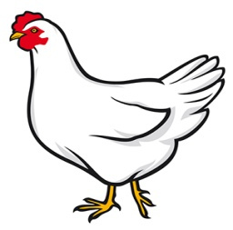
POULTRY
4-H PROJECT RECORD

(Maximum two photos per animal/item)

# of Years in Project ____

This year’s goals:

Project animal(s)/item(s):

What I did and learned in this project this year:

Achievements/Accomplishments:

Problems and solutions:

Where/who I received help from and how they helped:

Examples of leadership or growth:

When choosing animals to improve your breeding flock, what were the characteristics you were looking for and why were these traits important to you?

Future goals:

Poultry Flock Record

Inventory

Species  (Chicken, duck, etc.) | Number of animals | Breed(s) | Value of Sept. 1 or purchase/hatch date | Value as of Aug. 31 or sale price
 |  | Totals
Transfer values to your financial report.

Poultry Financial Report

(Total of all animals)
Expenses:
- Poultry flock beginning value (from Poultry Flock Record):
- Feed cost: (cost/bag: $ , total feed used in lbs: #)
- Bedding cost:
- Health records and veterinary costs:
Date | Condition treated | Treatment used | Other information  (withhold times) | Cost

- Supply costs: (List supplies purchased on chart below with each cost)
Date | Item purchased | Cost

- Transportation: (if none, mark N/A)
- Entry fees: (if none, mark N/A)
- Other expenses: (if none, mark N/A)
Total expenses (A through H):
Income:
- Poultry ending value (from Poultry Flock Record):
- Fair premium(s):
- Sale of eggs:
- Other income: (if none, mark N/A)
Total income (I through L):
Profit or Loss:

MY 4-H YEARLY PROJECT-RELATED ACTIVITIES

(4-H AND NON 4-H ACTIVITIES)
(Maximum two photos per EVENT)

Date: Event:

What I did and learned:

Date: Event:

What I did and learned:

