Dodge County
Record Book

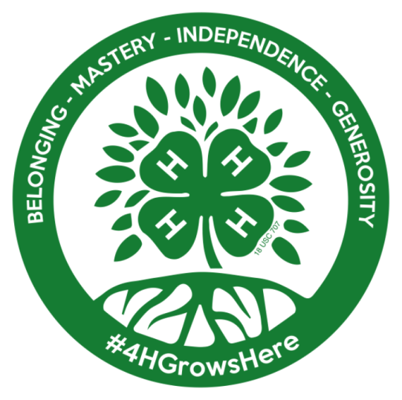

2nd Grade Cloverbud

Photo

Name:
Address:
Club Name:
Years in 4-H:
Grade at the start of the 4-H year:
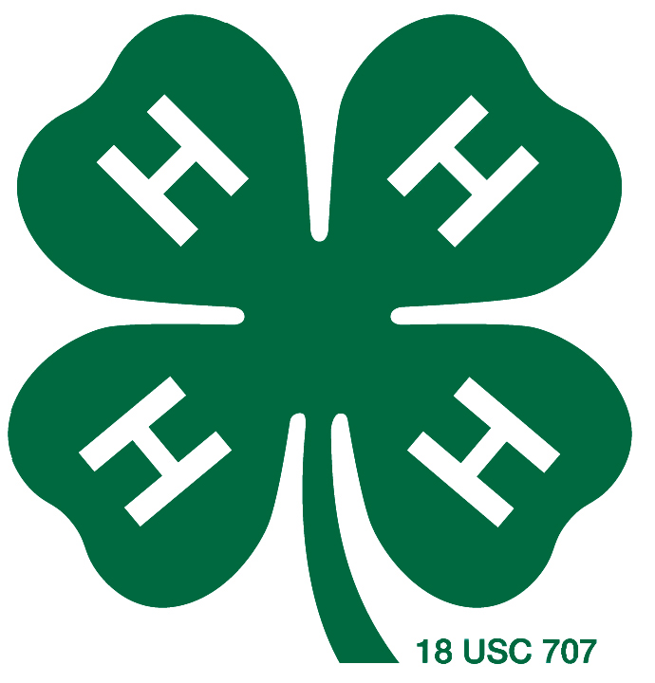
CUMULATIVE 4-H PROJECT LIST

Name of Project | Year  ____ | Year  ____ | Year  ____ | Year  ____ | Year  ____ | Year  ____ | Year  ____ | Year  ____ | Year  ____
Cloverbud

Transfer the form to the next year’s record book.

MY 4-H YEARLY SUMMARY AND GOALS

Number of meetings held by my club this year:
Number I attended:

What will you do this year to expand your 4-H experience and to help you grow as a person? (HINTS: This should be completed at enrollment time. Are there activities that you are going to take part in? Will you try to attend more meetings? …etc.)

____________________________________________________________________________________________________________________________________________________________________________________________________________________________________________________________________________________________________________________________________________________________________________________________________________________________________________________________________________________________________________________________________________________________
______________________________________________________

______________________________________________________

MY 4-H YEARLY ACTIVITIES SUMMARY

(NON-PROJECT ACTIVITIES)
(Maximum two photos per EVENT)

Date: ________________________ Event: ____________________________

What I did and learned:

______________________________________________________________________________________________________________________________________________________________________________________________________________________________________________________________________________

Add additional pages if needed
CLOVERBUD
4-H PROJECT RECORD

(Maximum two photos per item)

This year’s goals:
__________________________________________________________________________________________________________________________________________________________________
Project item(s):

What I did and learned in this project this year:
______________________________________________________________________________________________________________________________________________________________________________________________________________________________________________________________________________
____________________________________________________________________________________________________________
Achievements/Accomplishments:

________________________________________________________________________________________________________________________________________________________________________________________________________________________________________________________________________________________________________________________________________________________________________________________________________________________________________________
Problems and solutions:
________________________________________________________________________________________________________________________________________________________________________________________________________________________________________________________________________________________________________________________________________________________________________________________________________________________________________________

Where/who I received help from and how they helped:
____________________________________________________________________________________________________________________________________________________________________________________________________________________________________________________________________________________________________________________________________
Future goals:
______________________________________________________________________________________________________________________________________________________________________________________________________________________________________________________________________________

MY 4-H YEARLY PROJECT-RELATED ACTIVITIES

(4-H ACTIVITIES)
(Maximum two photos per EVENT)

Date: ________________________ Event: ____________________________

What I did and learned:

______________________________________________________________________________________________________________________________________________________________________________________________________________________________________________________________________________

Add additional pages if needed

PARENT/LEADER COMMENTS

(Optional)
(Special/unusual situation should be documented by leader, parents, or one familiar with youth’s abilities.)

