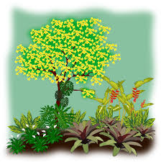
HOME GROUNDS
4-H PROJECT RECORD

(Maximum two photos per item)

# of Years in Project ____

This year’s goals:

Project item(s):

What I did and learned in this project this year:

Achievements/Accomplishments:

Problems and solutions:

Where/who I received help from and how they helped:

Examples of leadership:

Future goals:

Project financial report:
(Income includes: estimated value of item if you would/did sell it, fair premium(s), and income from jobs pertaining to the project.)

Income and Expenses
Date | Description | Income | Expense
Totals
Net Profit or Loss
Home Grounds
(If does NOT apply, write N/A)

Describe your home grounds:

How large is your home grounds area?

What type(s) of fertilizer did you use?

What did you do to control weeds?

What did you do to control pests?

What type of equipment did you use (rake, shovel, tractor, rototiller, soaker hose, sprinkler, etc.)?

Describe the weather conditions and how they affected your grounds:

How often did you water?

Did you conduct a soil test? What did the results show?

Were other planting materials used (mulch, rock, etc.)? What was the purpose?

MY 4-H YEARLY PROJECT-RELATED ACTIVITIES

(4-H AND NON 4-H ACTIVITIES)
(Maximum two photos per EVENT)

Date: Event:

What I did and learned:

Date: Event:

What I did and learned:

