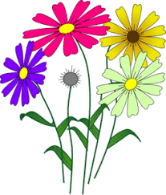
FLOWERS
4-H PROJECT RECORD

(Maximum two photos per item)

# of Years in Project ____

This year’s goals:

Project item(s):

What I did and learned in this project this year:

Achievements/Accomplishments:

Problems and solutions:

Where/who I received help from and how they helped:

Examples of leadership or growth:

Future goals:

Project financial report:
(Income includes: estimated value of item if you would/did sell it, fair premium(s), and income from jobs pertaining to the project.)

Income and Expenses
Date | Description | Income | Expense
Totals
Net Profit or Loss

Flowers

(If does NOT apply, write N/A)

List plants that were purchased (include dates purchased):

List plants that were started from seed (include dates planted):

List plants that were carried over from previous year(s):

Did you plant in pots? Flowerbeds? How large is your area?
What type(s) of fertilizer did you use?

What did you do to control weeds?

What did you do to control pests?

What type of equipment did you use (rake, shovel, tractor, rototiller, soaker hose, sprinkler, etc.)?

Describe the weather conditions and how they affected your plants:

How often did you water your plants?
Did you conduct a soil test? What did the results show?
Describe the type of potting soil used:

Were other planting materials used (mulch, rock, black plastic, etc.)? What was the purpose?

MY 4-H YEARLY PROJECT-RELATED ACTIVITIES

(4-H AND NON 4-H ACTIVITIES)
(Maximum two photos per EVENT)

Date: Event:

What I did and learned:

Date: Event:

What I did and learned:

