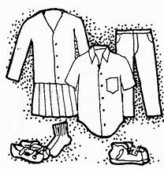
CONSUMMER SAVVY
4-H PROJECT RECORD

(Maximum two photos per item)

# of Years in Project _______

This year’s goals:

Project item(s):

What I did and learned in this project this year:

Achievements/Accomplishments:

Problems and solutions:

Where/who I received help from and how they helped:

Examples of leadership or growth:

Future goals:

Project financial report:
(Income includes: estimated value of item if you would/did sell it, fair premium(s), and income from jobs pertaining to the project)

Income and Expenses
Date | Description | Income | Expense
Totals
Net Profit or Loss

Consumer Savvy
Purchased Outfit Fact Sheet

(Outfit may contain more than one item)
Use a separate sheet for each item bought

Item bought:
1. Selecting your garment:
a. What type of fabric is the item constructed from? (circle one)
Woven Knit Non-woven
2. Garment and purchased facts:
  - Type of fabric:
  - Where purchased:
  - Fiber content:
3. Cost of item:
Price paid:

Retail price:
Transfer this information to your consumer savvy financial report.
Net Gain/Net Loss:

Construction details (Explain how you examined the item on how it was constructed):

Care of garment (Describe how you will care for this item):

MY 4-H YEARLY PROJECT-RELATED ACTIVITIES

(4-H AND NON 4-H ACTIVITIES)
(Maximum two photos per EVENT)

Date: Event:

What I did and learned:

Date: Event:

What I did and learned:

