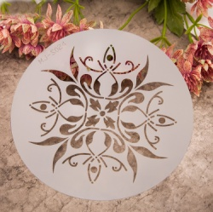
STENCIL PAINTING
4-H PROJECT RECORD

(Maximum two photos per item)

This year’s goals:

Project item(s):

What I did and learned in this project this year:

Achievements/Accomplishments:

Problems and solutions:

Where/who I received help from and how they helped:

Examples of leadership:

Future goals:

Project financial report:
(Income includes: estimated value of item if you would/did sell it, fair premium(s), and income from jobs pertaining to the project)

Income and Expenses
Date | Description | Income | Expense
Totals
Net Profit or Loss

Stencil Painting

Use a separate sheet for each item made
(If does NOT apply, write N/A)

Source of idea:

Pattern name/number:

Brief description of item made:

Materials used:

Techniques used:

Describe how you will care for this item:

Approximate time spent making item:

MY 4-H YEARLY PROJECT-RELATED ACTIVITIES

(4-H AND NON - 4-H ACTIVITIES)
(Maximum two photos per EVENT)

Date: Event:

What I did and learned:

Date: Event:

What I did and learned:

