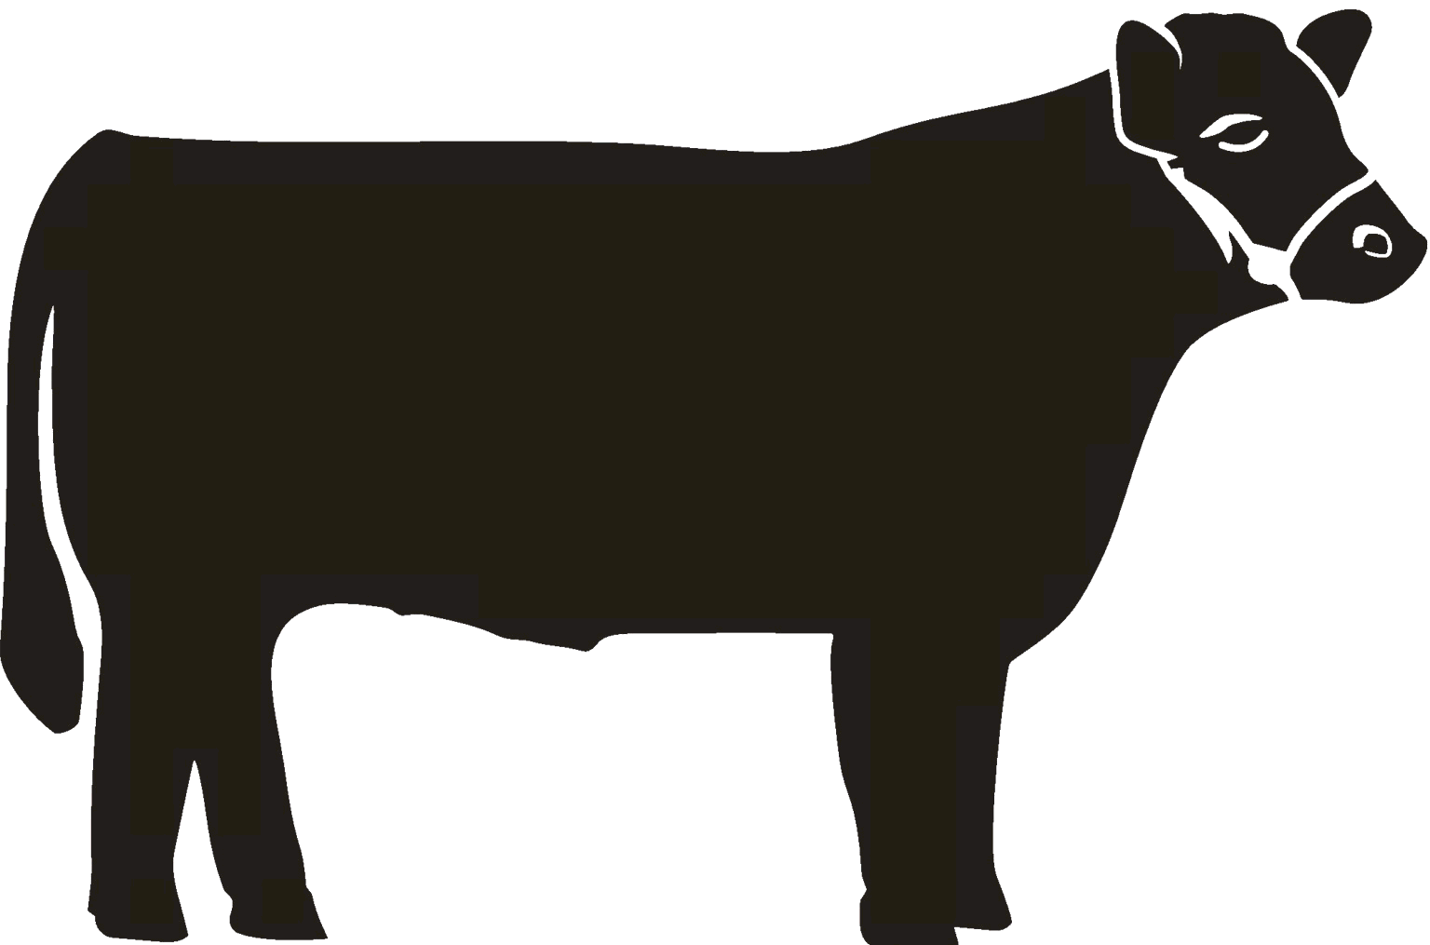
BEEF
4-H PROJECT RECORD

(Maximum two photos per animal/item)

This year’s goals:

Project animal(s)/item(s):

What I did and learned in this project this year:

Achievements/Accomplishments:

Problems and solutions:

Where/who I received help from and how they helped:

Examples of leadership:

When choosing animals to improve your breeding herd, what were the characteristics you were looking for and why were these traits important to you?

Future goals:
Market Beef Report

Animal tag #: Purchase price or value: $
Starting weight (if unable to weigh your animal at home, mark N/A):
Fair weight (finished weight):
Rate of gain (if no starting weight, mark N/A):
Animal sold for: $ Market price per pound: $

Animal tag #: Purchase price or value: $
Starting weight (if unable to weigh your animal at home, mark N/A):
Fair weight (finished weight):
Rate of gain (if no starting weight, mark N/A):
Animal sold for: $ Market price per pound: $

Animal tag #: Purchase price or value: $
Starting weight (if unable to weigh your animal at home, mark N/A):
Fair weight (finished weight):
Rate of gain (if no starting weight, mark N/A):
Animal sold for: $ Market price per pound: $

Market Beef Financial Report

(Total of all animals from Market Beef Report)

Expenses:
- Purchase price or beginning value (from Market Beef Report): $
- Feed cost: $ (cost/bag: $ , total feed used in lbs: #)
- Bedding cost: $
- Health records and veterinary costs: (List below any vaccination used, worming and other herd health treatment plan protocol)
Date | Condition treated | Treatment used | Other information  (withhold times) | Cost

- Supply costs: (List supplies purchased on chart below with each cost)
Date | Item purchased | Cost

- Transportation (if none, mark N/A): $
- Entry fees (if none, mark N/A): $
- Other expenses (if none, mark N/A): $
Total expenses (A through H): $
Income:
- Sale of animal(s): $
- Fair premium(s): $
- Other income (if none, mark N/A): $
Total income (I through K): $
Profit or Loss: $
Beef Breeding Stock Record

(exhibited animals only)

Inventory

Calves/Heifers/  Cows/Bulls | Number of animals | Breed |  | Value as of Sept. 1 or purchase/born date | Value as of Aug. 31 or sell date
 |  |  | Totals
Transfer the end value to your financial report.

Beef Breeding Stock Financial Report

(Total of all animals from Beef Breeding Stock)
Expenses:
- Total beginning animal inventory value (from Beef Breeding Stock Record): $
- Total feed cost: $ (cost/bag: $ , total feed used in lbs: #)
- Total bedding cost: $
- Health records and veterinary costs: (List below any vaccination used, worming and other health treatment plan protocol)
Date | Condition treated | Treatment used | Other information  (withhold times) | Cost

- Supply costs (List supplies purchased on chart below with each cost)
Date | Item purchased | Cost

- Transportation (if none, mark N/A): $
- Entry fees (if none, mark N/A): $
- Other expenses (if none, mark N/A): $
Total expenses (A through H): $
Income: $
- Total ending animal inventory value (from Beef Breeding Stock Record): $
- Sale of animal(s): $
- Fair premium(s): $
- Other income (if none, mark N/A): $
Total income (I through L): $
Profit or Loss: $

MY 4-H YEARLY PROJECT-RELATED ACTIVITIES

(4-H AND NON - 4-H ACTIVITIES)
(Maximum two photos per EVENT)

Date: Event:

What I did and learned:

Date: Event:

What I did and learned:

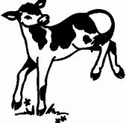
BEEF FEEDER
4-H PROJECT RECORD

(Maximum two photos per animal/item)

This year’s goals:

Project animal(s)/item(s):

What I did and learned in this project this year:

Achievements/Accomplishments:

Problems and solutions:

Where/who I received help from and how they helped:

Examples of leadership:

Future goals:

Beef Feeder Report

*Attach Receipt/Proof of Value. This page must be completed and turned in at the fair weigh-in. Failure to complete this form accurately will result in a last place penalty for this portion of your score.

Animal I.D. #:
Animal purchase price:
Starting date: Starting weight:
End date: End weight: Rate of gain:

Animal I.D. #:
Animal purchase price:
Starting date: Starting weight:
End date: End weight: Rate of gain:

Animal I.D. #:
Animal purchase price:
Starting date: Starting weight:
End date: End weight: Rate of gain:

Beef Feeder Financial Report

(Total of all animals from Beef Feeder Report)
Expenses:
- Purchase price or beginning value (from Beef Feeder Report):
- Feed cost: $ Milk replacer (cost/bag: $ , total feed used in lbs: #)
Grain (cost/bag: $ , total feed used in lbs: #)
Hay (cost/bale: $ , total feed used in lbs: #)
- Bedding cost:
- Health records and veterinary costs (List below any vaccination used, worming and other health treatment plan protocol)
Date | Condition treated | Treatment used | Other information  (withhold times) | Cost

- Supply costs (List supplies purchased on chart below with each cost)
Date | Item purchased | Cost

- Transportation (if none, mark N/A):
- Entry fees (if none, mark N/A):
- Other expenses (if none, mark N/A):
Total expenses (A through H):
Income:
- Sale of animal(s):
- Fair premium(s):
- Other income (if none, mark N/A):
Total income (I through K):
Profit or Loss:

MY 4-H YEARLY PROJECT-RELATED ACTIVITIES

(4-H AND NON - 4-H ACTIVITIES)
(Maximum two photos per EVENT)

Date: Event:

What I did and learned:

Date: Event:

What I did and learned:

